EXAMPLE FINAL CONCEPT PAPER
Team Lead: Orville Wright
Team: Team Kitty Hawk
Organization: The Wright Company
Team Reference Number: 00000000000
Projected Payload-to-Weight Ratio: 4:1
1. Design Updates
Since the draft submission, the primary update has been the successful fabrication and bench testing of our custom lightweight engine. The initial concept of a cast aluminum-copper alloy crankcase has been realized, bringing the total engine weight to under 200 pounds while reliably producing over 8 horsepower. This innovation remains the cornerstone of achieving our projected 4:1 payload-to-weight ratio, a significant improvement over the state-of-the-art.
The engine has been integrated into the finalized airframe. The final design remains true to the initial concept, with the now-proven engine serving as the key enabling technology.
The following elements detail the final design of the Wright Flyer:
- Propulsion: The aircraft is powered by a single, custom-built 4-cylinder, 4-stroke internal combustion engine. It uses standard automotive gasoline with a total fuel volume of less than 1 gallon housed in a small tank mounted to a wing strut.
- Power System: The engine utilizes a self-contained, gear-driven magneto for spark ignition. There is no battery or external electrical power system on the aircraft.
- Drive Train/Power Transmission: Power is transmitted from the engine to two counter-rotating propellers via a chain-and-sprocket system, similar to that used in bicycles.
- Aerodynamic Design: The Wright Flyer is a canard biplane, with the elevator (for pitch control) located at the front. Roll control is achieved through a wing-warping mechanism where the pilot uses a hip cradle to twist the wings. A rear-mounted rudder provides yaw control. The pilot operates from a prone position on the lower wing to reduce aerodynamic drag.
- Structure and Materials: The airframe is a Pratt truss design constructed primarily from Spruce for its high strength-to-weight ratio, with some components made of Ash. The wings and control surfaces are covered in unbleached muslin fabric.
- Flight Controller: The aircraft is controlled manually and mechanically by the pilot. There is no electronic flight controller or autopilot system. All control inputs are direct mechanical linkages. The system does not operate on any RF frequency.
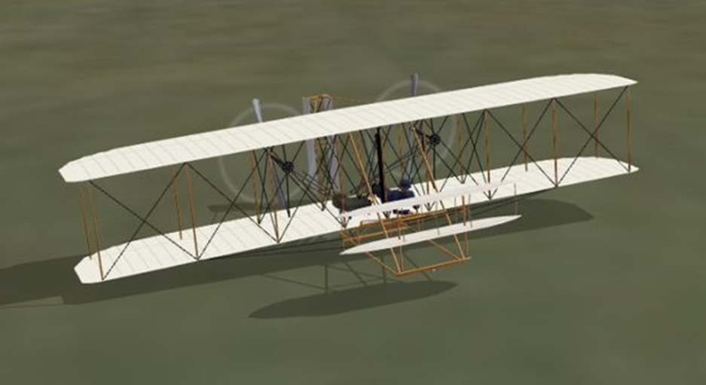
  - Rotating Lift Component
The following data is provided for the propellers:
- Structure and Materials: Laminated layers of hand-carved Spruce
- Weight of component: Approximately 15 lbs per propeller
- Speed/RPM: Approximately 350 RPM during flight.
  - Spectrum List
The Wright Flyer contains no components that emit radio frequencies. All systems are mechanical.
  - Energy Type and Amount
Type of Fuel: Automotive Gasoline
Approximate Volume for Storage: A single 5-gallon, DOT-approved safety can of gasoline will be stored on location.

2. Preliminary Hazard Analysis
Hazard | Severity | Likelihood | Mitigation Strategy
Engine Failure | High | High | Pilot is trained for unpowered glides. All flights are planned over flat, open ground (sand) to allow for a survivable forced landing.
Structural Failure (Wing/Strut) | Catastrophic | Medium | Airframe is constructed with high-quality spruce. All bracing wires are checked for proper tension before each flight. Wing-warping is limited in initial tests to avoid over-stressing the airframe.
Loss of Control | Catastrophic | High | The canard (forward elevator) design provides some stall resistance. The pilot has extensive experience on gliders with similar control systems. Initial flights will be short, low-altitude hops in calm winds.
Propeller Chain Derailment | High | Medium | Chain tension is inspected rigorously before every flight. A simple guide system is in place to prevent the chain from slipping off the sprockets during operation.

3. Emergency Procedures and Remote Pilot in Command Checklists
Pre-Flight Checklist:
1. Check weather conditions (wind speed below 15 mph).
2. Inspect entire airframe, including fabric, struts, and bracing wires, for any signs of damage.
3. Verify full and free movement of the elevator and rudder controls.
4. Test wing-warping mechanism for smooth operation.
5. Inspect engine, fuel level, and propeller drive chains for tension and integrity.
6. Ensure the launch rail is clear of obstructions.
Emergency Procedures (Engine Failure in Flight):
1. Immediately establish a stable glide by pushing the elevator control forward to lower the nose and maintain airspeed.
- Assess the landing area and identify a clear path for touchdown, directly ahead if possible.
- Use gentle wing-warping and rudder inputs to maintain control and alignment with the landing path.
- Just before touchdown, pull back on the elevator to flare the aircraft and land on the skids.

Post-Flight Checklist:
1. Shut down the engine.
- Conduct a thorough inspection of the airframe and engine for any stress, cracks, or damage.
- Record flight duration, distance, and any observations or anomalies in the flight log.
- Secure the aircraft against wind.

